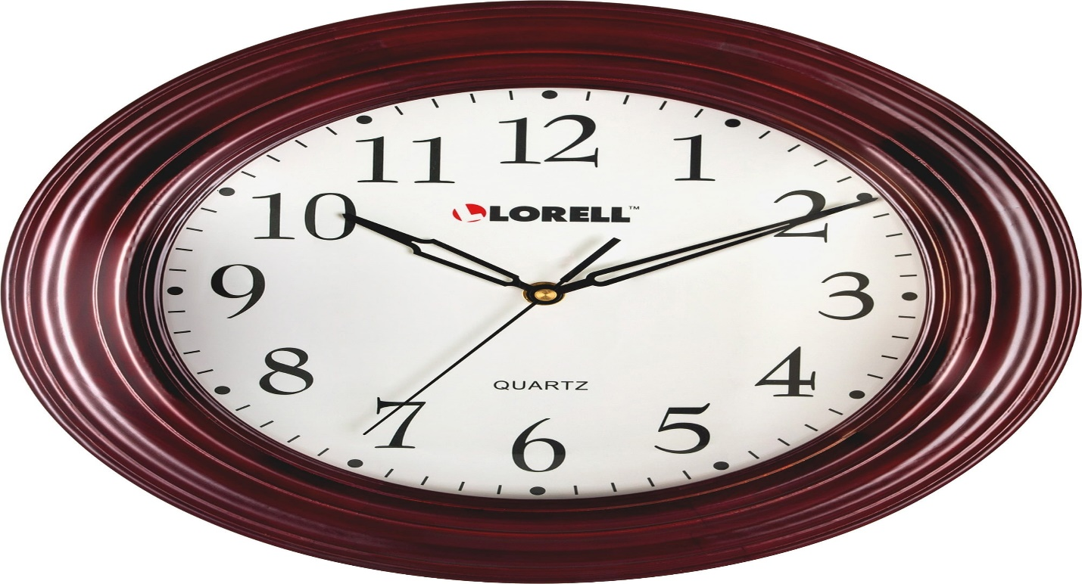**Description:** **Lorell** is a well-known brand that offers a range of affordable and reliable office and home furnishings, including wall clocks. Lorell clocks are designed with functionality and simplicity in mind, making them ideal for workplaces, schools, and homes. They are often characterized by their clean, easy-to-read dials, durable construction, and battery-operated quartz movement for accurate timekeeping. Many Lorell clocks come in classic round or modern designs, featuring shatter-resistant covers and bold numerals for enhanced visibility. As part of the broader Lorell brand, which focuses on office solutions, their clocks are valued for their affordability, practicality, and reliability, making them a popular choice for professional environments.